

Lab No:04 Date:2082/09/13
Title: Studying fragmentation in distributed database horizontal and vertical fragmentation.
Fragmentation is the process of dividing a database table into smaller parts called fragments, which are stored on different sites in a distributed system. Each fragment is a logical unit of data, and together.
Horizontal fragmentation splits a table by rows based on conditions on one or more attributes. Each fragment contains a subset of rows, which are then stored at different sites. This helps in localizing data access.
Vertical fragmentation splits a table by columns (attributes), storing different columns on different sites. Since each site may not need all columns, this improves efficiency. To reconstruct the original table, each fragment must include a common key (like the primary key or a tuple ID) so that rows can be joined correctly using a natural JOIN.
Site A is simply the local Oracle database where you are currently logged in. Oracle does not require a command like CREATE SITE A.
The database you are connected to in SQL*Plus is Site A by default.
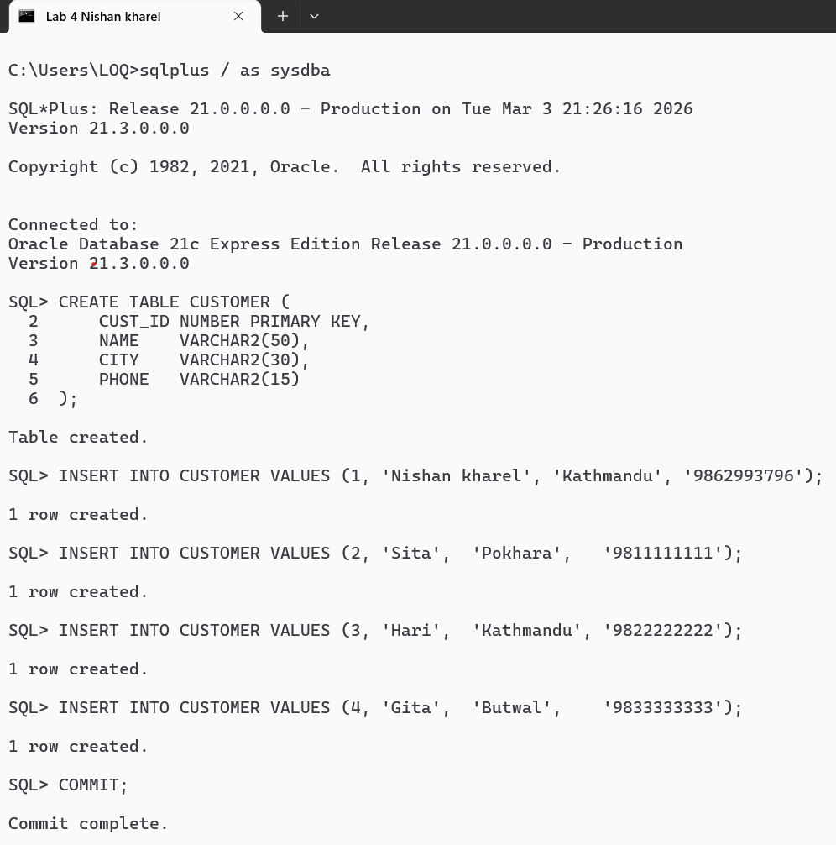

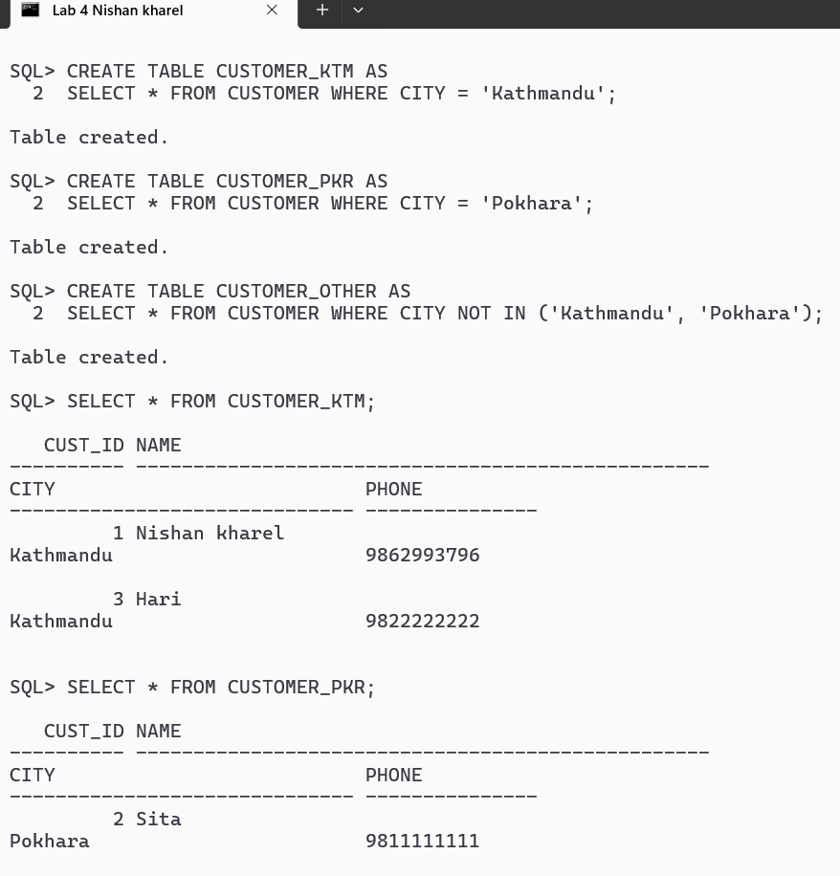
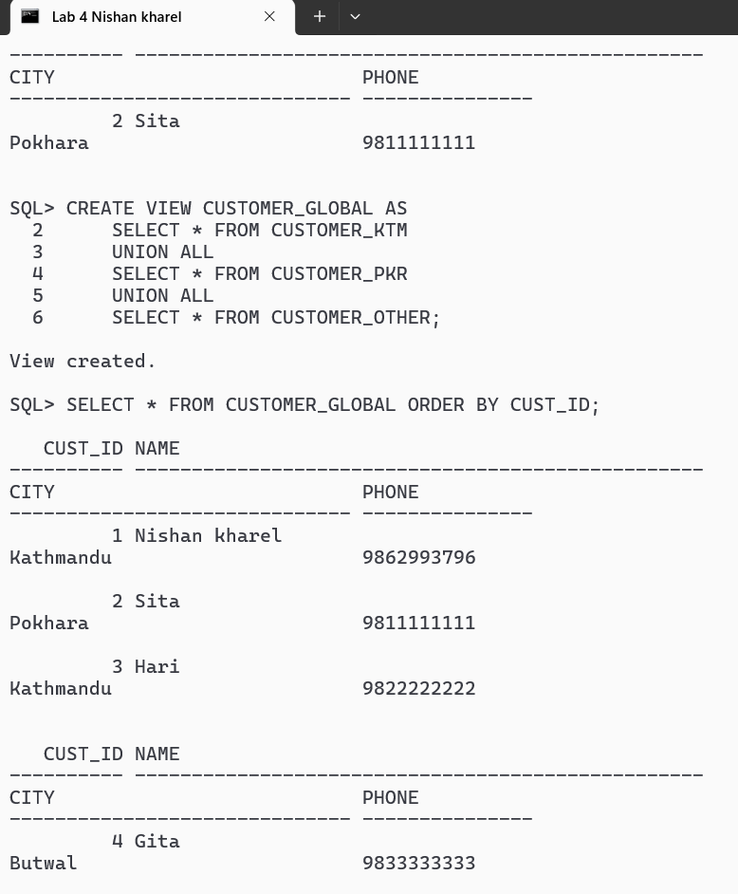

Horizontal fragmentation was implemented by dividing the CUSTOMER table based on CITY attribute and storing fragments at different sites. A global view was defined to provide transparent access to distributed data.
Vertical fragmentation divides the EMPLOYEE table into personal info and work info fragments stored at different locations. The global view EMPLOYEE_GLOBAL joins these fragments using the primary key to reconstruct the full table, providing transparent access to distributed data.
πa1, a2,..., an (T)
π is relational algebra operator
a1...., an are the attributes of T
T is the table (relation)
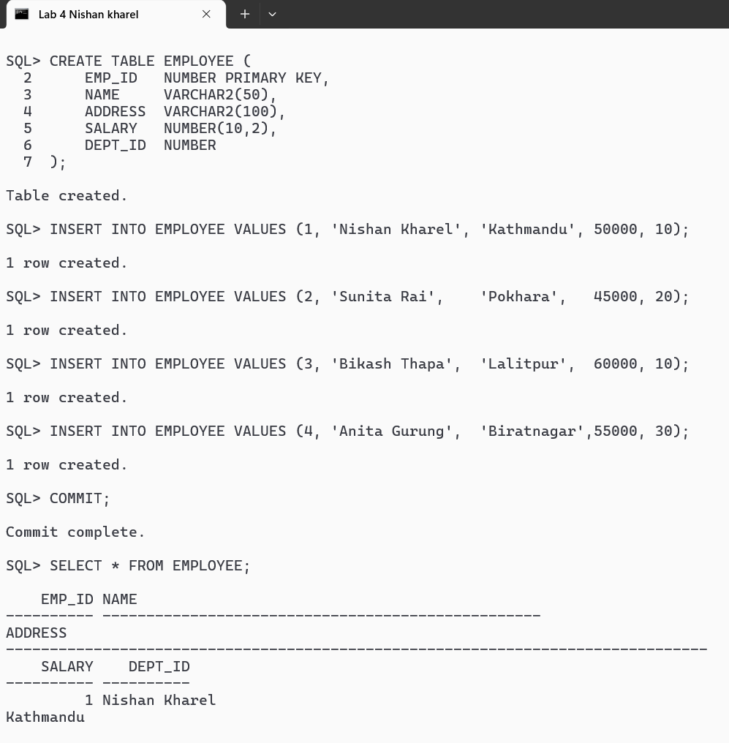
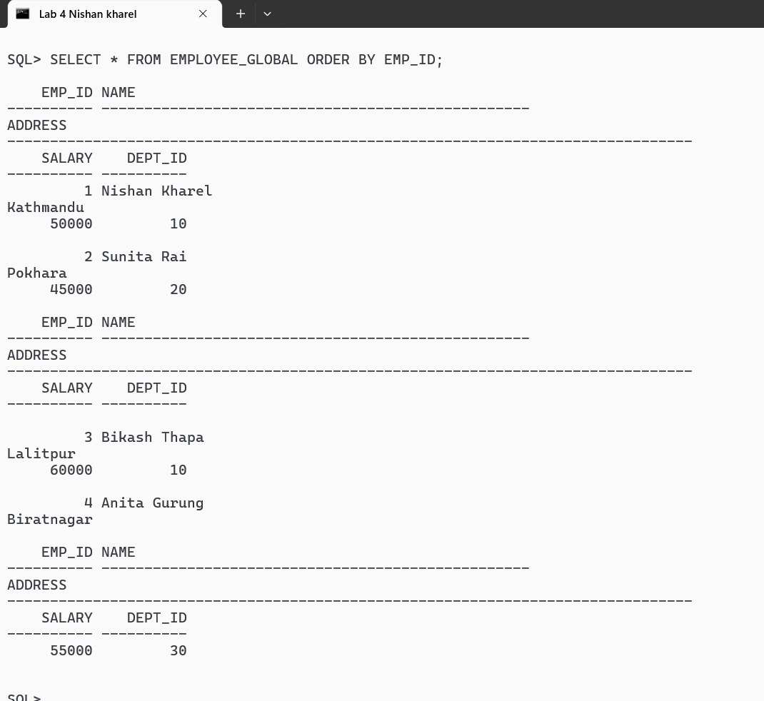

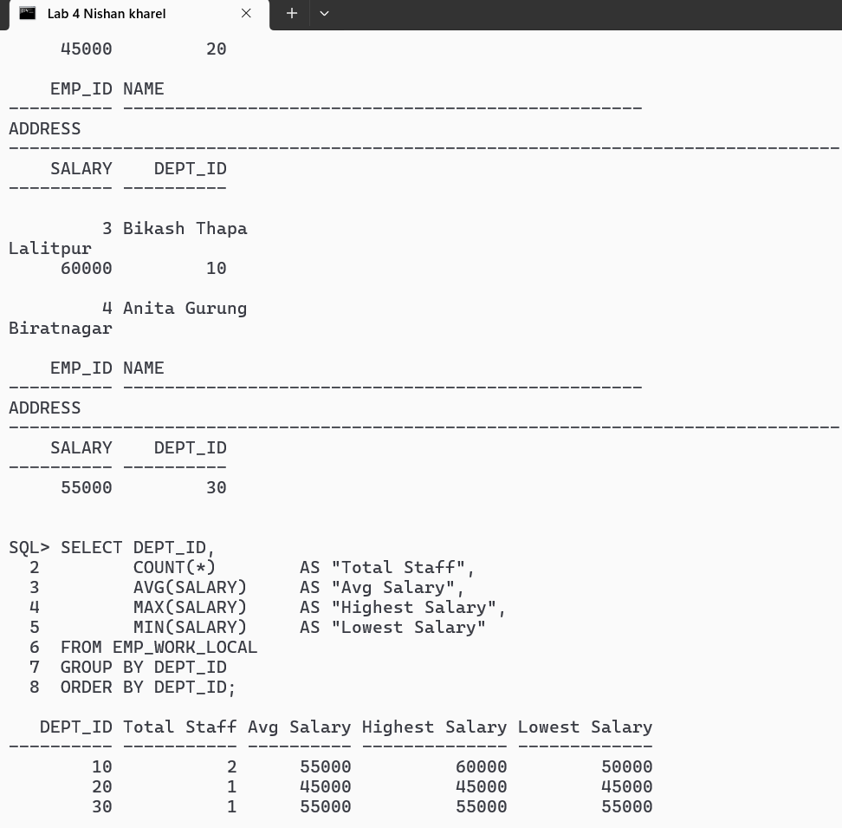

Vertical fragmentation is a technique in distributed databases where a table is split column-wise into multiple fragments. In your project, the EMPLOYEE table was divided into two fragments: EMP_PERSONAL, containing EMP_ID, NAME, and ADDRESS, and EMP_WORK_LOCAL, containing EMP_ID, SALARY, and DEPT_ID. The primary key EMP_ID is present in both fragments to allow reconstruction of the original table. A global view EMPLOYEE_GLOBAL was created by joining the two fragments on EMP_ID, which provides transparent access to the full employee data. Even though the work fragment was simulated locally instead of using a remote site, the reconstruction works correctly. Querying the global view shows all columns and rows as in the original table. This demonstrates that vertical fragmentation separates data for storage efficiency while maintaining the ability to retrieve the complete information when needed. Overall, this method effectively illustrates how column-based data distribution and reconstruction are implemented in Oracle.

